

***CSS Essentials***

**Assignments**

|  |  |
| --- | --- |
| Document Code | 25e-BM/HR/HDCV/FSOFT |
| Version | 1.1 |
| Effective Date | 20/11/2012 |

**Hanoi, 04/2019**

RECORD OF CHANGES

|  |  |  |  |  |  |
| --- | --- | --- | --- | --- | --- |
| No | Effective Date | Change Description | Reason | Reviewer | Approver |
|  | 25/Jun/2018 | Create a new Lab | Create new | DieuNT1 | VinhNV |
|  | 01/May/2019 | Update Fsoft Template | Update | DieuNT1 | VinhNV |
|  |  |  |  |  |  |
|  |  |  |  |  |  |
|  |  |  |  |  |  |
|  |  |  |  |  |  |
|  |  |  |  |  |  |
|  |  |  |  |  |  |
|  |  |  |  |  |  |
|  |  |  |  |  |  |

Contents

Unit 3 – Selectors 4

Objectives: 4

Project Structure 4

Problem 1: 4

Problem 2: 4

Problem 3: 5

Problem 4: 6

Problem 5: 7

|  |  |
| --- | --- |
|  | **CODE: CSS-E.M.A301**  **TYPE: Medium**  **LOC: N/A**  **DURATION: 60 MINUTES** |

# Unit 3 – Selectors

Objectives:

* Understand Selectors of CSS

Project Structure

* A project called **CSS-E.M.A301** (this will be your root folder) is provided to you
* Put your work for each problem in corresponding folder inside root folder

Problem 1:

Without changing the HTML, use CSS to do the following things to recreate the expected output

* Make h1 headings blue.
* Give h2 headings a blue background and white text.
* Cause text wrapped in a span to have a font-size of 200%.

Expected output:

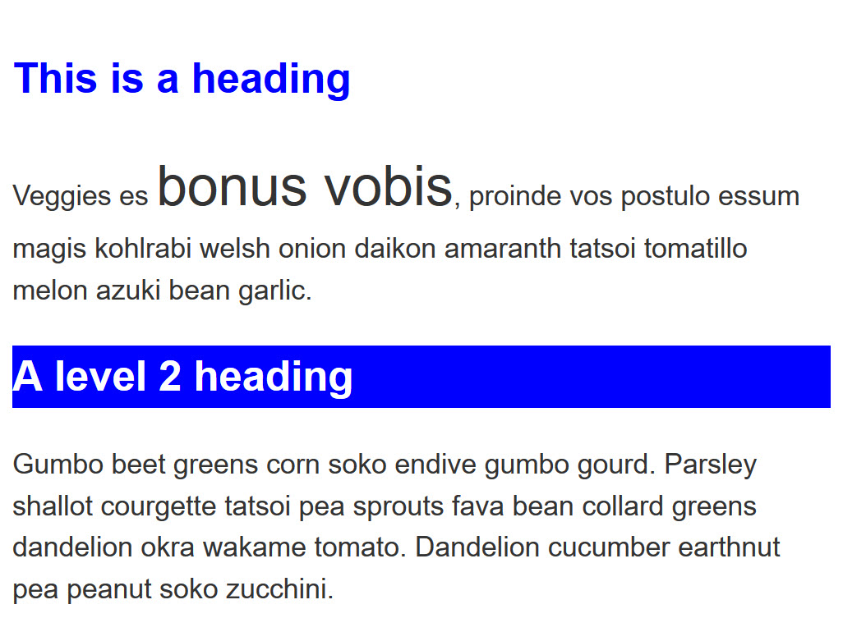

Problem 2:

Without changing the HTML, make the following changes to the look of the content in this example:

1. Give the element with an id of special a yellow background.
2. Give the element with a class of alert a 1px grey border.
3. If the element with a class of alert also has a class of stop, make the background red.
4. If the element with a class of alert also has a class of go, make the background green.

Expected output:

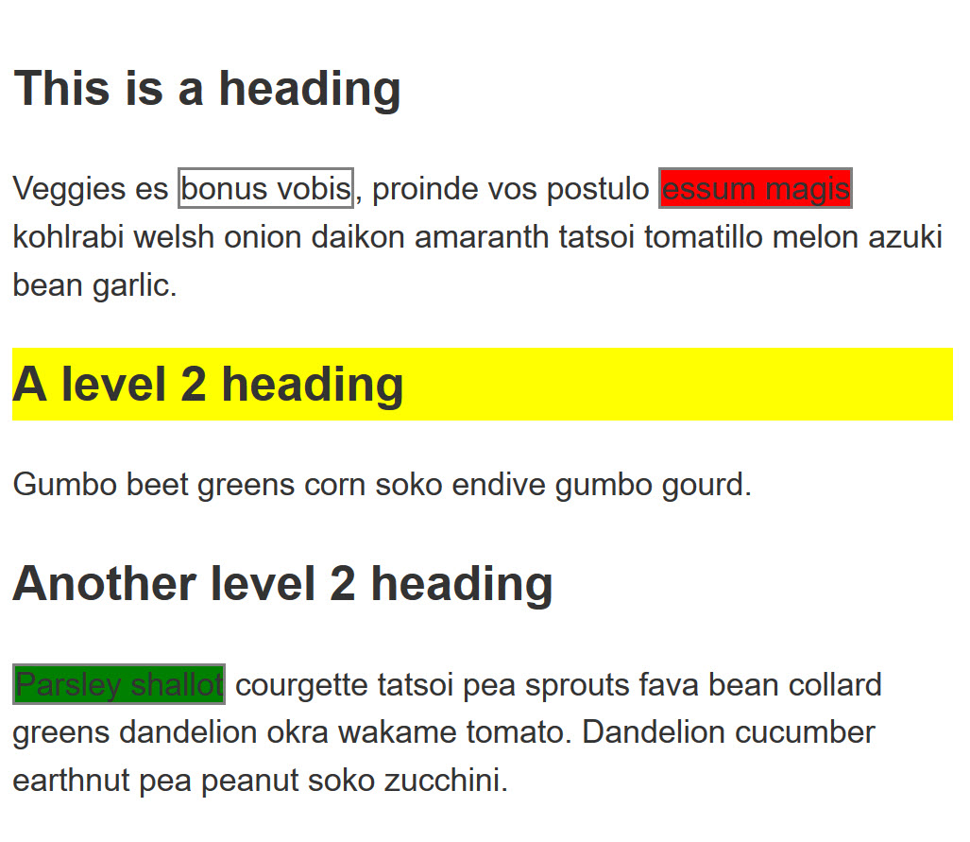

Problem 3:

In this example, try making the following changes without adding to the HTML.

1. Style links, making the link-state orange, visited links green, and remove the underline on hover.
2. Make the first element inside the container font-size: 150% and the first line of that element red.
3. Stripe every other row in the table by selecting these rows and giving them a background color of #333 and foreground of white.

Expected output

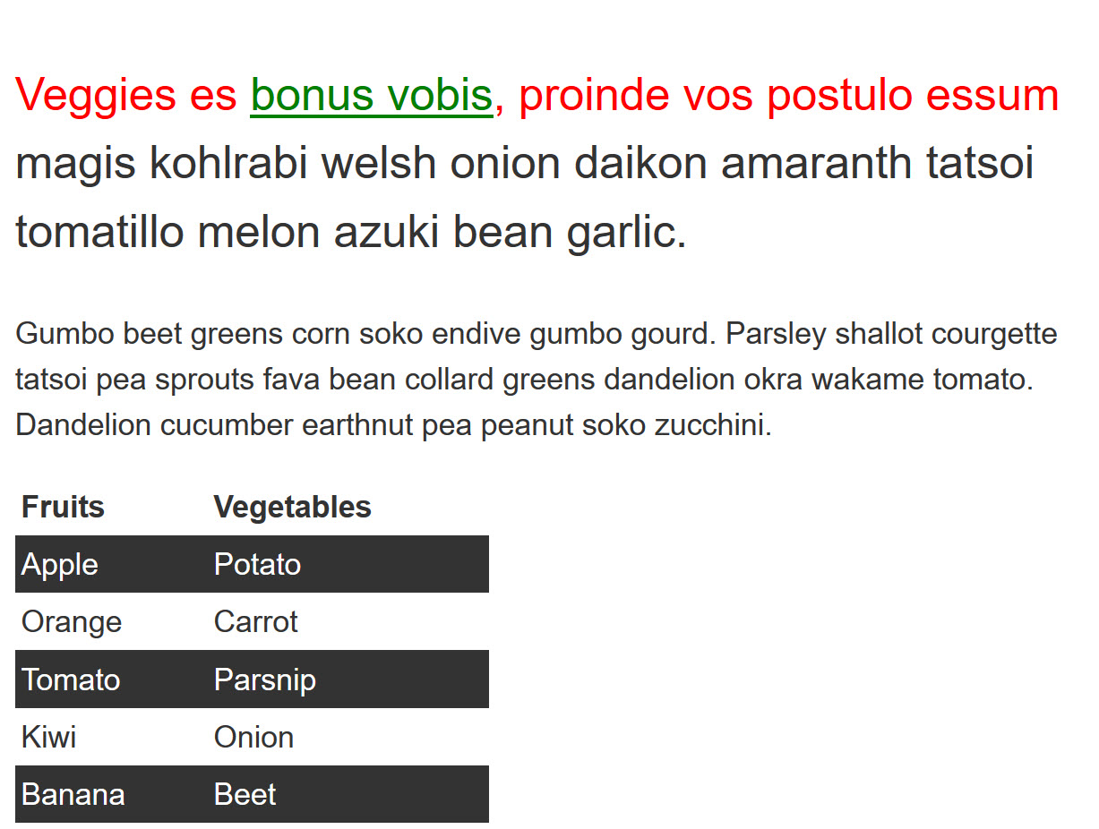

Problem 4:

In this task try the following:

1. Make any paragraph that directly follows an h2 element red.
2. Remove the bullets and add a 1px grey bottom border only to list items that are a direct child of the ul with a class of list.

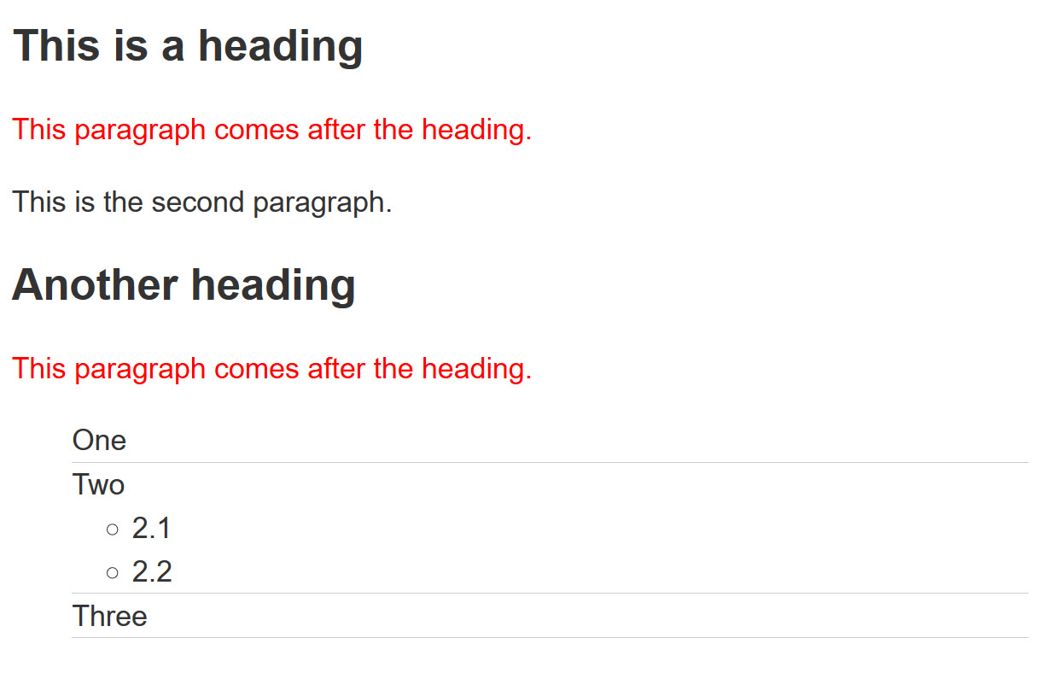

Problem 5:

In this final task add CSS using attribute selectors to do the following:

1. Target the <a> element with a title attribute and make the border pink (border-color: pink).
2. Target the <a> element with an href attribute that contains the word contact somewhere in its value and make the border orange (border-color: orange).
3. Target the <a> element with an href value starting with https and give it a green border (border-color: green).

Expected output

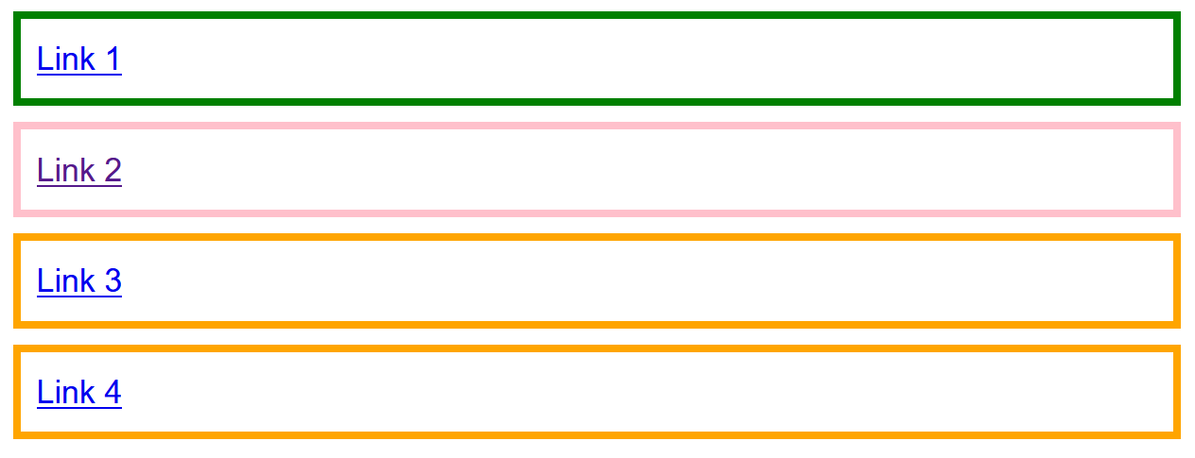

**-- THE END --**